1. **Create a Inventory Management System for a small shop.**

**Create a database named InventoryDB**

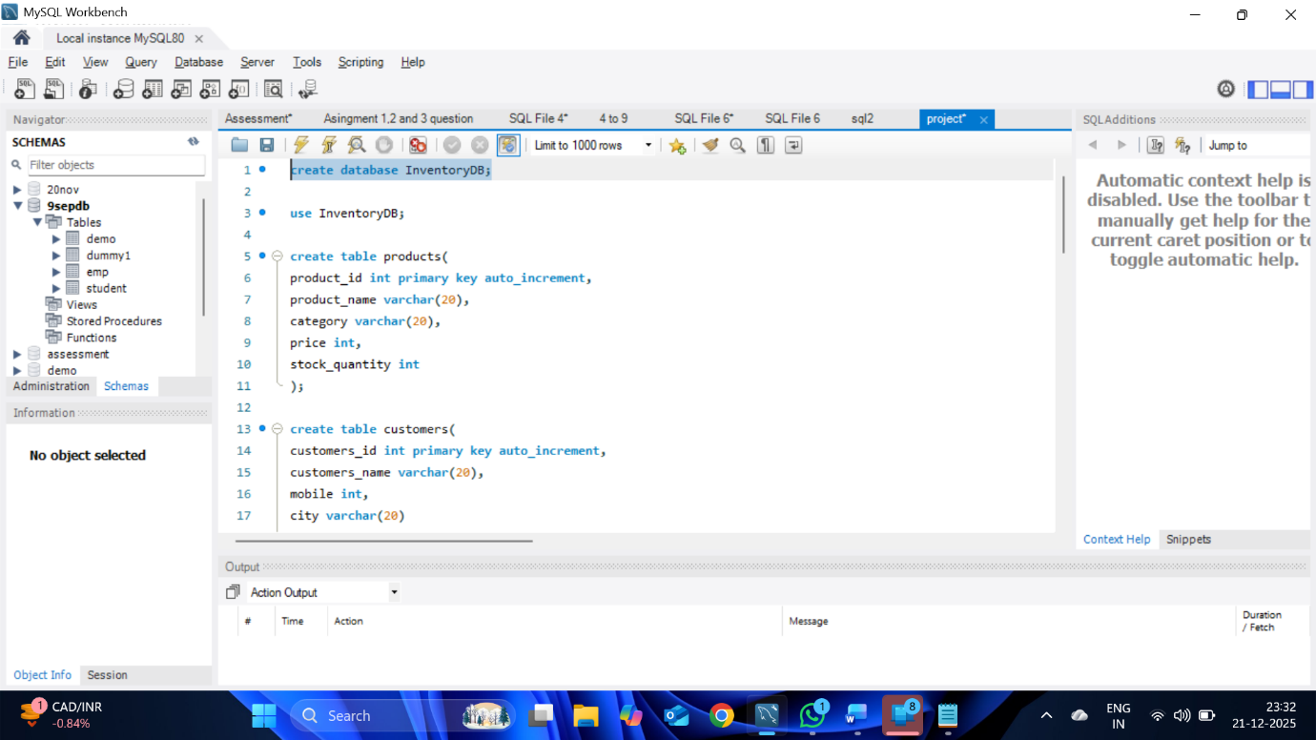

1. **Switch to this database.**

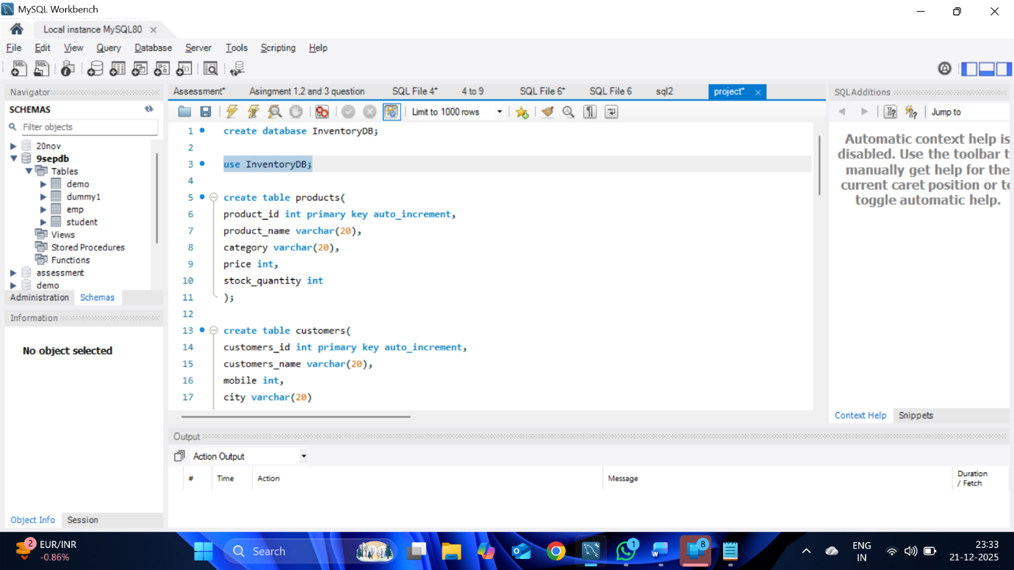

**3.** **Create Two Tables**

**1. products**

**Fields:**

**-> product_id → (Primary key, Auto Increment)**

**-> product_name**

**-> category**

**-> price**

**-> stock_quantity**

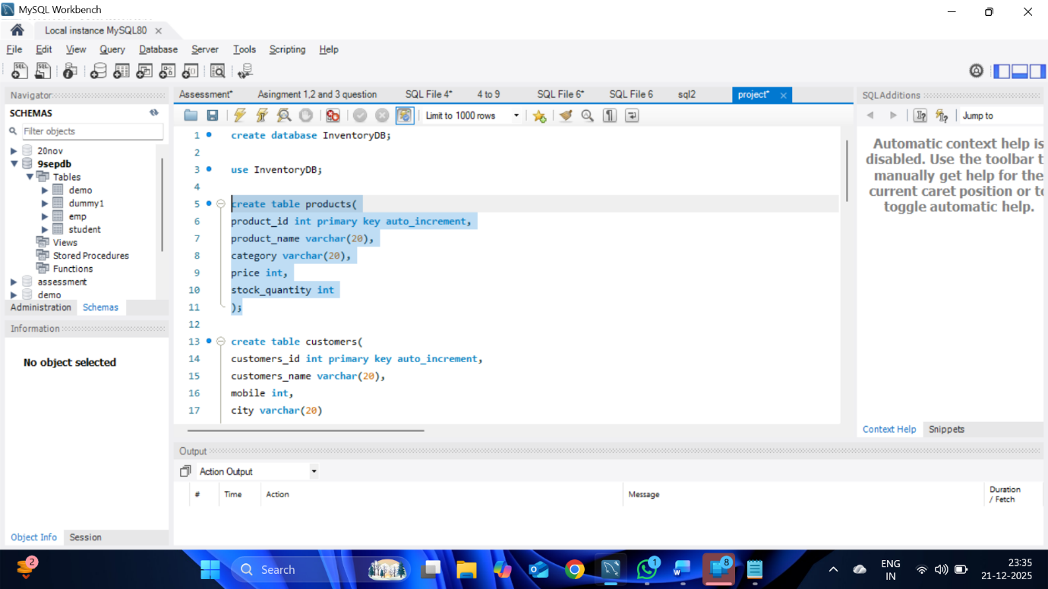

**2. customers**

**Fields:**

**-> customer_id → (Primary key, Auto Increment)**

**-> customer_name**

**-> mobile**

**-> city**

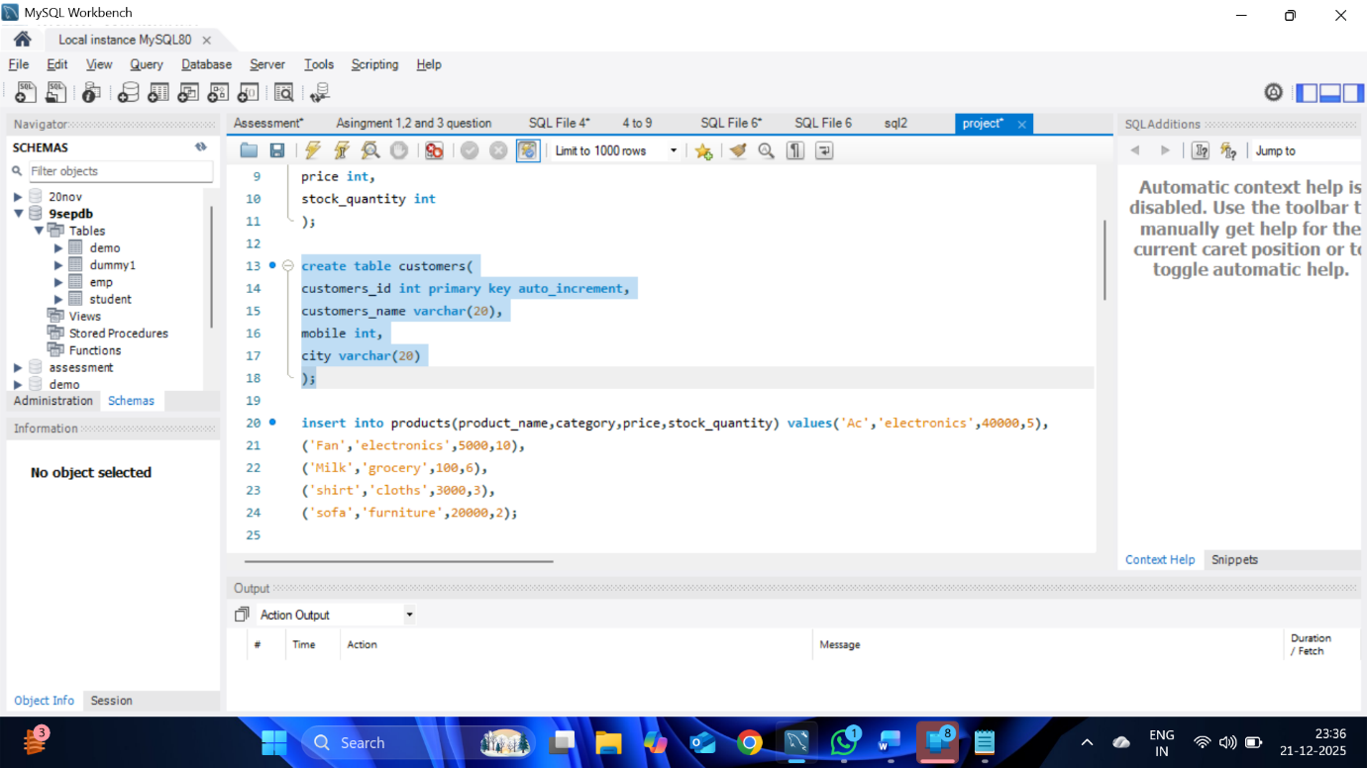

**4 . Insert Records**

**Products Table**

**Insert minimum 5 products**

**(Example categories: Electronics, Grocery, Clothing — students choose)**

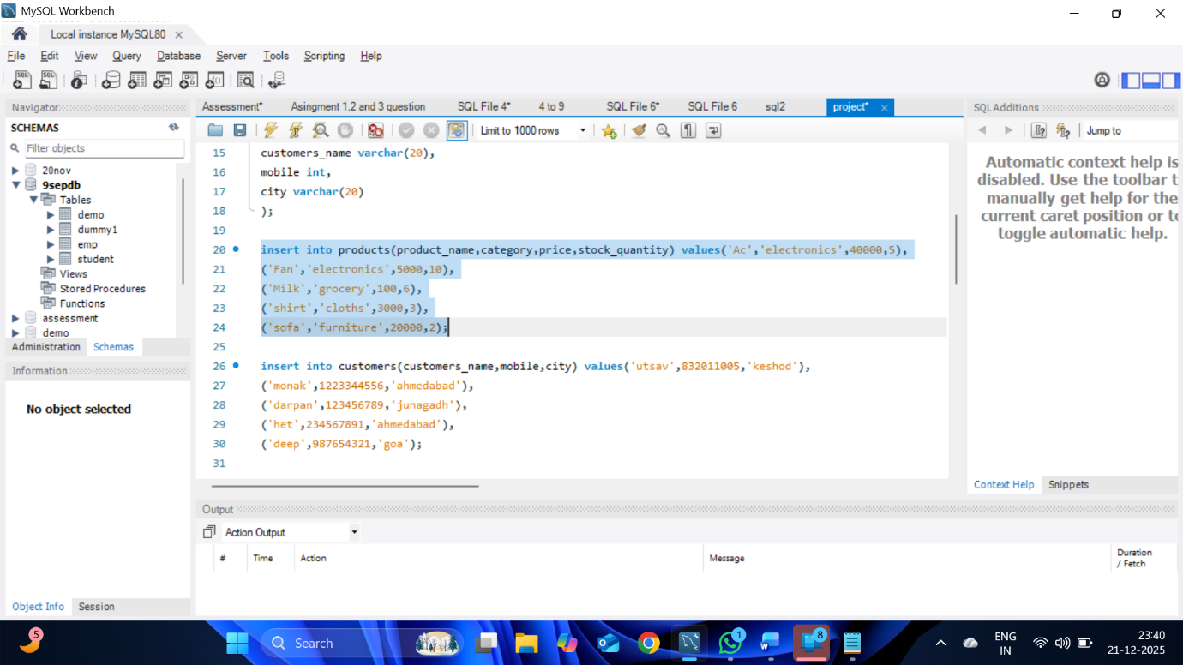

**Output :-**

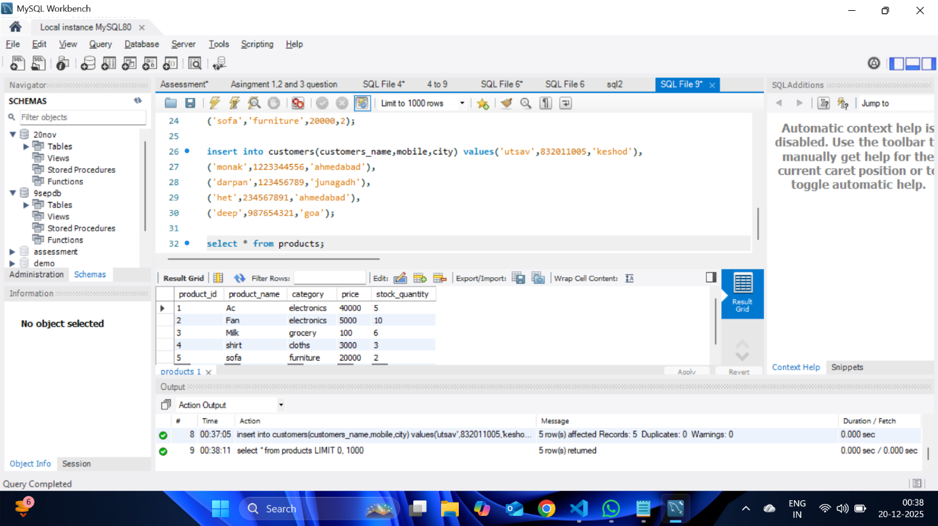

**5 . Customers Table**

**Insert minimum 5 customers**

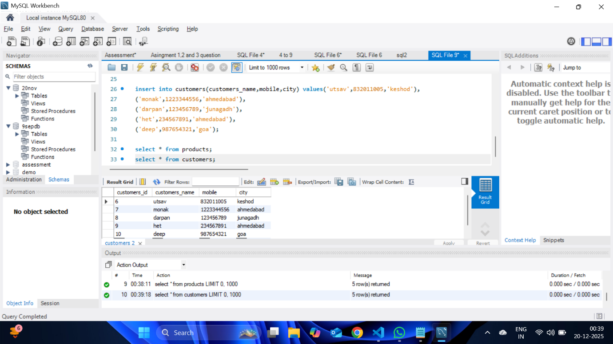

**6 . Show products only from category “Electronics”**

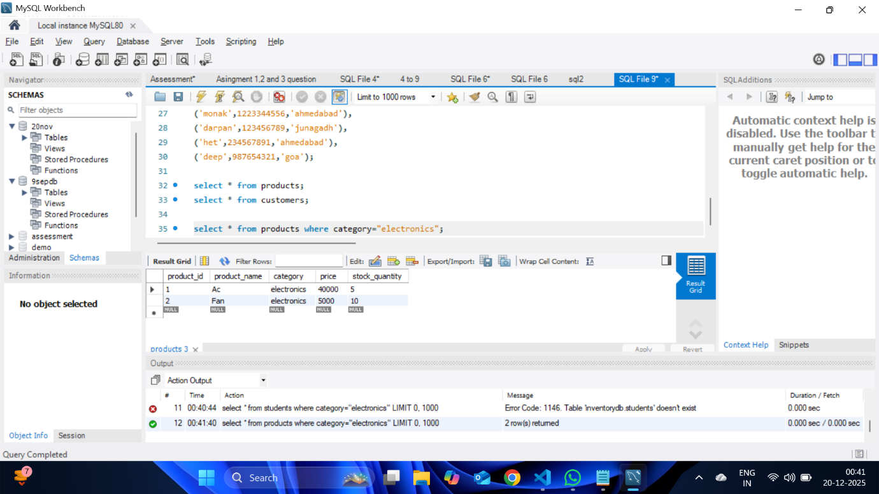

**7 . Show customers from a specific city**

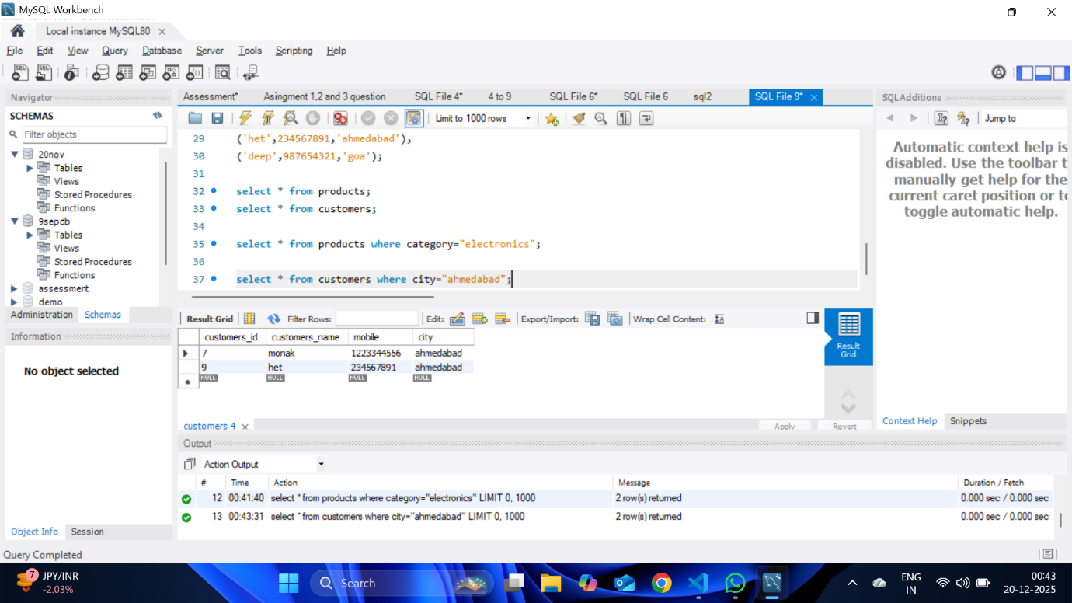

**8 . Show products whose price is greater than 5000**

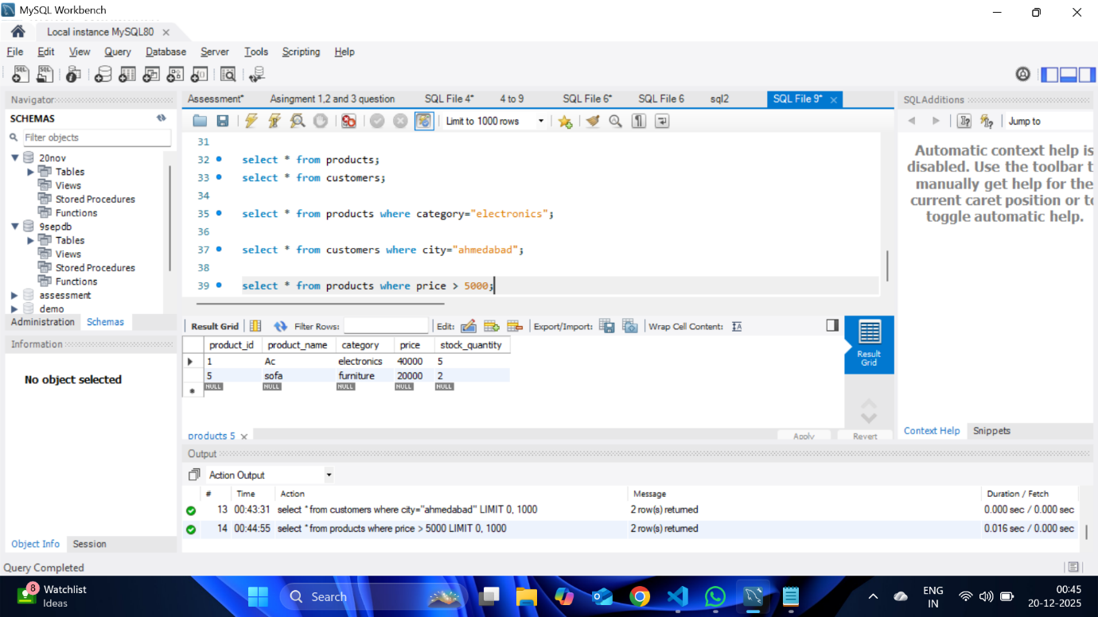

**9 . Show products whose stock is less than 10**

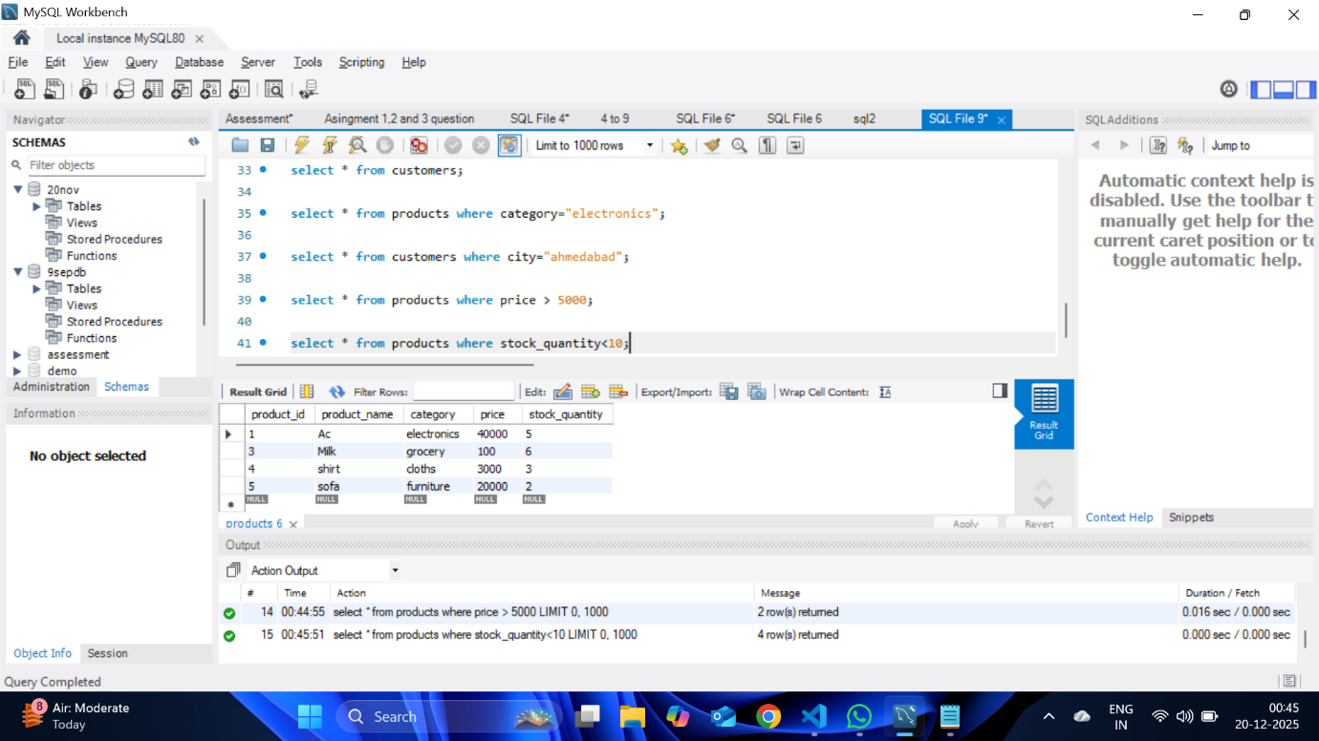

**10. Change price of any one product**

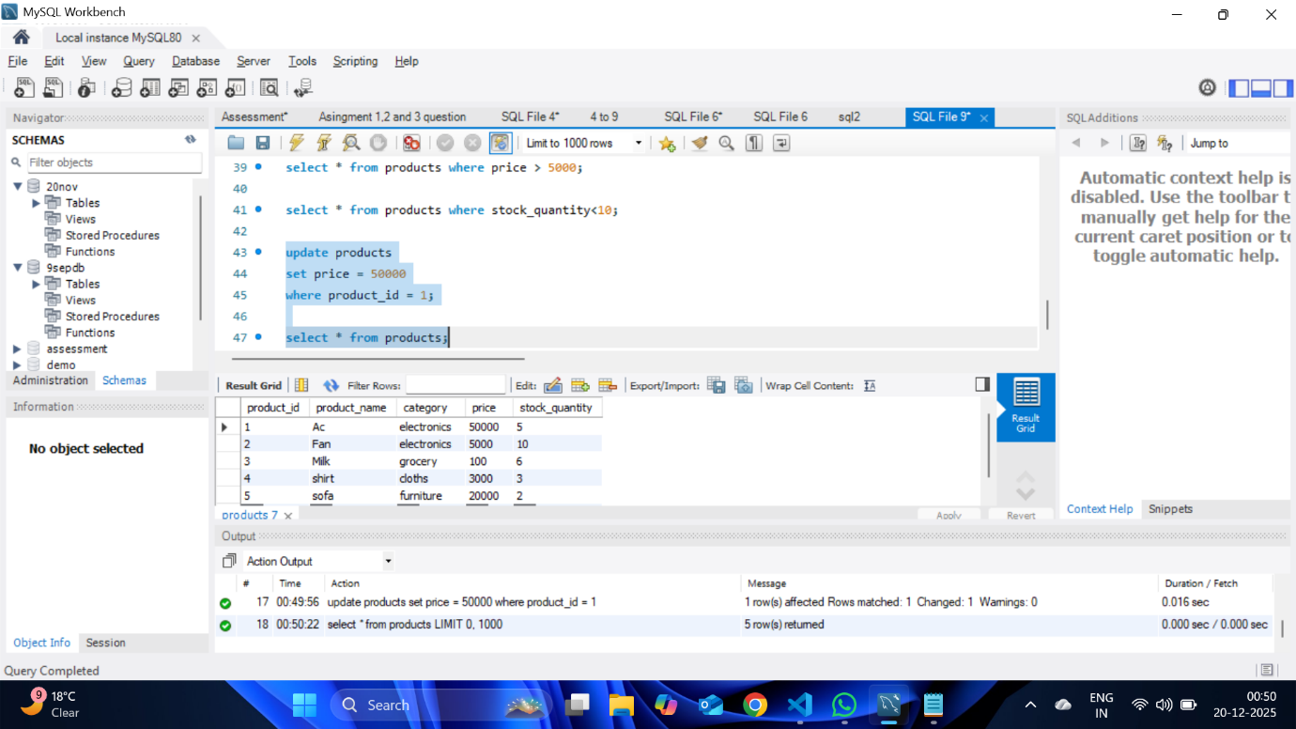

**11 . Change stock of any product**

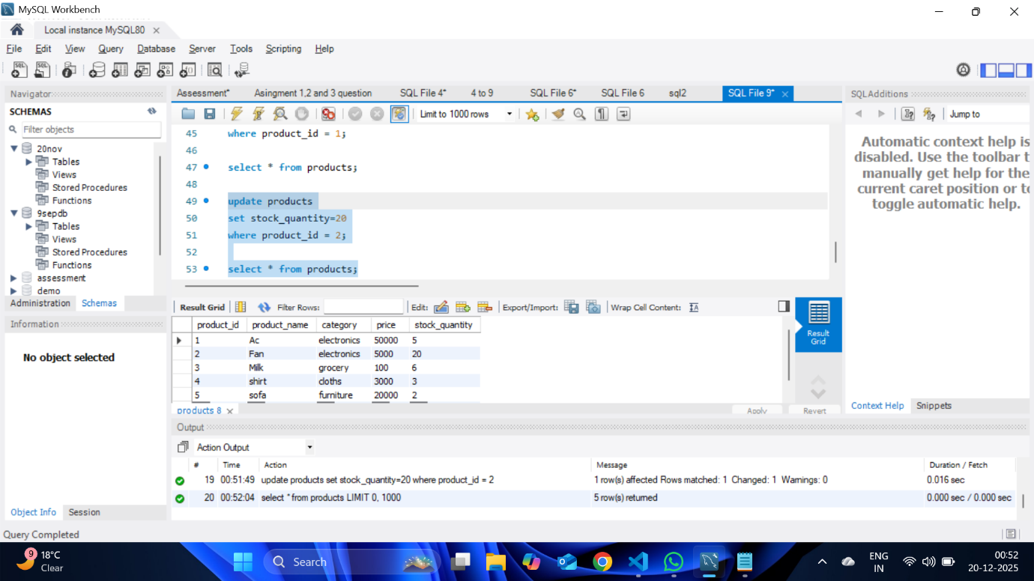

**12 . Update customer city**

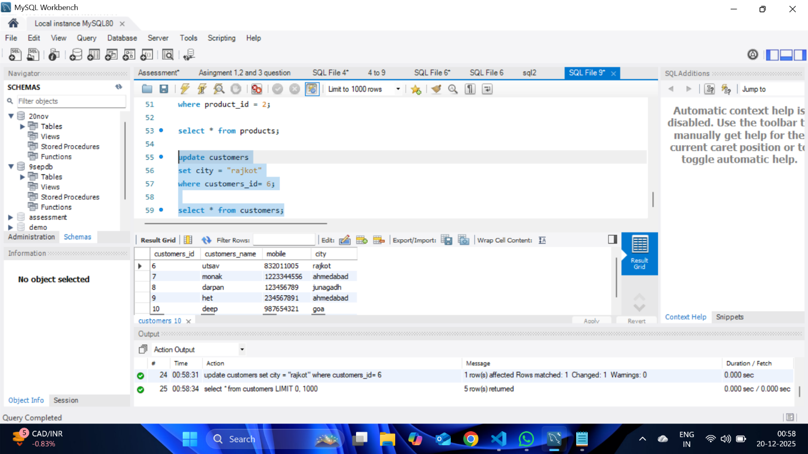

**13. Update customer mobile number**

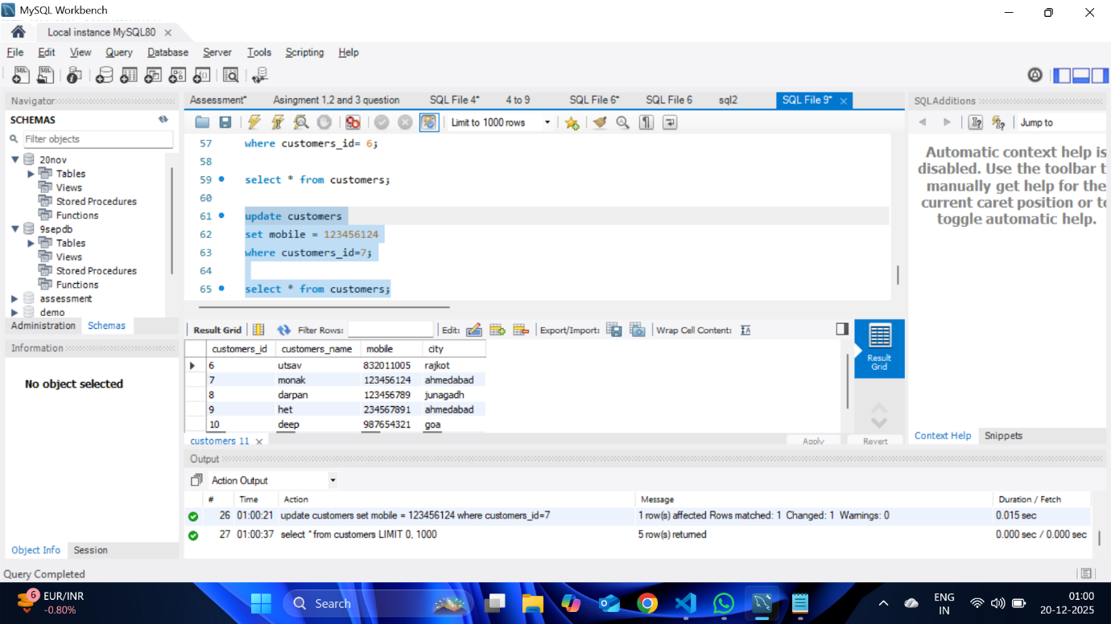

**14. Delete One product**

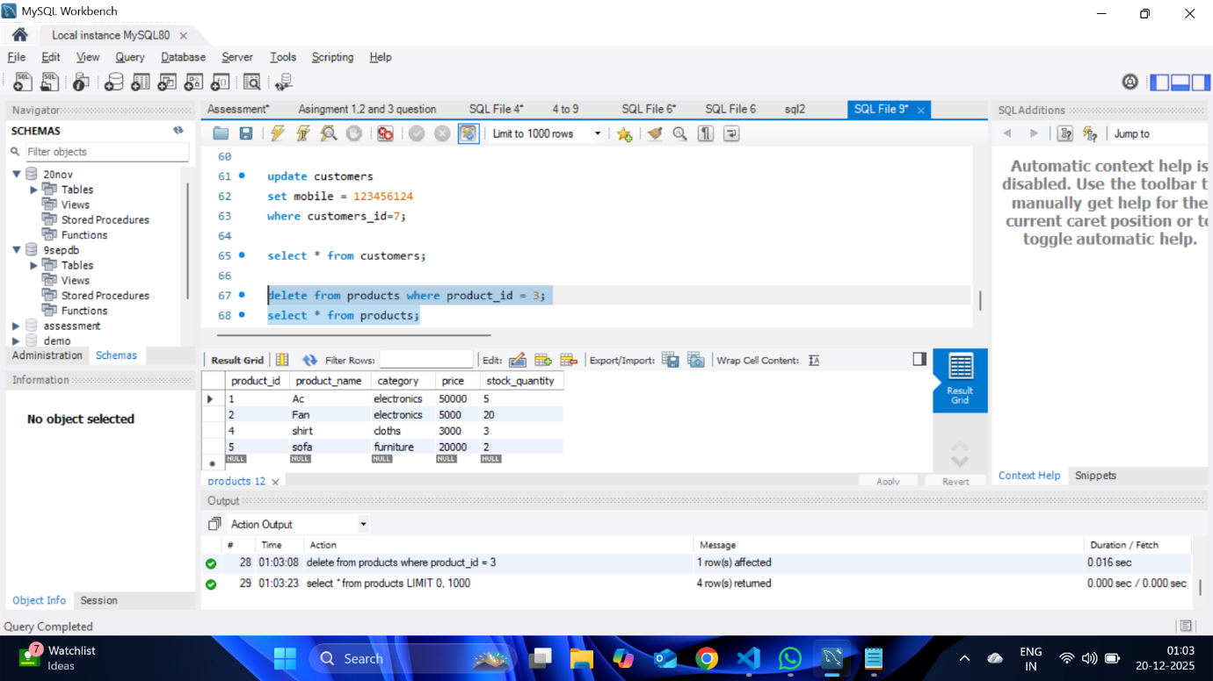

**15. Delete One customer**

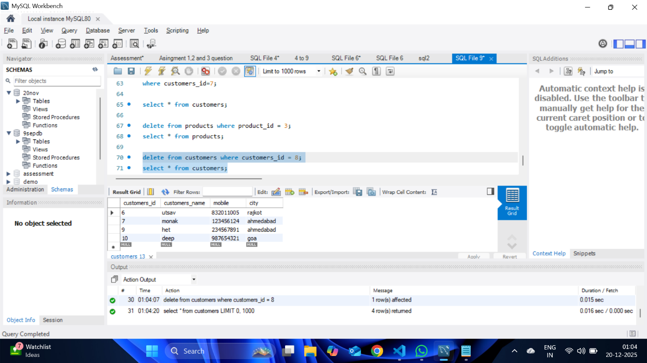

**16. Delete all products from a specific category (example: Grocery)**

